**Name : Jiamiao Chen Wednesday, March 8, 2023**

**BMEN E4580**: Fundamentals of Nanobioscience and Nanobiotechnology

Midterm Exam

1. Complete the following Table with examples of objects at that size scale. (4 points)

|  |  |  |
| --- | --- | --- |
| Biology | Size | Technology |
| Fungus | 1 km | Skyscraper in Dubai |
| Blue whale | 10 m | Bus |
| Giant squid neuron | 1 m | Children’s Bike |
| Beetle | 1 cm | SIM card |
| Human egg cell | 100 μm | Microfluidic device |
| Bacteria | 1 μm | Polymers |
| Protein | 10 nm | Transistor |
| Atom | 1 A | Tip of Scanning Tunneling Microscope (STM) |

Having this table in mind, what is the scope of nanobiotechnology? (1 point)

Nanobiotechnology interacts with biological system in the scale of from a few angstroms to couple of hundreds of nanometers.

2. What is an Atomic Force Microscope? How does it work? Make a sketch. (5 points)

An Atomic Force Microscope (AFM) is a variation of the Scanning Tunneling Microscope (STM). They both use a small probe called profilomer to scan over the surface of the sample and detect the topography of the surface. However, in AFM, as the probe scans across the surface, a laser beam is used to detect the deflection of the probe, which is indicative of its change in position.

1. Describe 3 types of microscopy. For each type, name one application. (6 points)

* Optical Microscopy is a common type of microscopy that uses visible light to magnify and observe samples. It has a relatively lower magnification and is mainly used to observe the morphology of cells or tissue structures.
* Electron Microscopy uses beams of electrons to observe samples. Beams of electrons pass through the sample and imprint its image, this is later magnified and observed. One application for electron microscope is to observe cellular structures such as mitochondria.
* Scanning Tunneling Microscope uses a physical probe with size scale in angstroms to observe samples at atomic scale. One application of STM is observing the structure of biological molecules such as DNA and proteins.

1. What is the resolution of a microscope with a numerical aperture of NA=1.49 and using a wavelength of λ = 600 nm?  (2 points)

Formula: $R= \frac{λ}{2*NA}$

$$R= \frac{λ}{2*NA}=\frac{600 nm}{2*1.49}≈201 nm$$

1. Name and describe two motor proteins. What are their similarities and their differences? (6 points)

* Kinesin motor proteins is a family of biological motor proteins. One of the most common types is kinesin 1, which has 2 heads that walk along microtubules and a long tail that binds to intracellular cargo.
* Myosin motor proteins is also a family of biological motor proteins. One of the most prominent members is Myosin II. It is dimeric with 2 heavy chains and 4 light chains. The heavy chains are structured into a head domain, which binds to actin filaments, and a tail domain. The 4 light chains support the operations of the heavy chains.
* Both Kinesin and myosin motor proteins use ATP as energy source. Both molecules have two heads that interacts with filament tracks and tail domain that interacts with other molecules.
* While kinesin molecules bind to microtubes, myosin molecules bind to actin filaments. While myosin is involved in muscle contraction and cell migration, kinesin is involved in intracellular transport of cargos such as vesicles.

1. The following figure is taken from the paper: “Selective Loading of Kinesin-Powered Molecular Shuttles with Protein Cargo and its Application to Biosensing” by S. Ramachandran, …., and Henry Hess*, small 2006, 2, No. 3, 330 – 334

What would you have done differently if you had prepared the figure? (1 point)

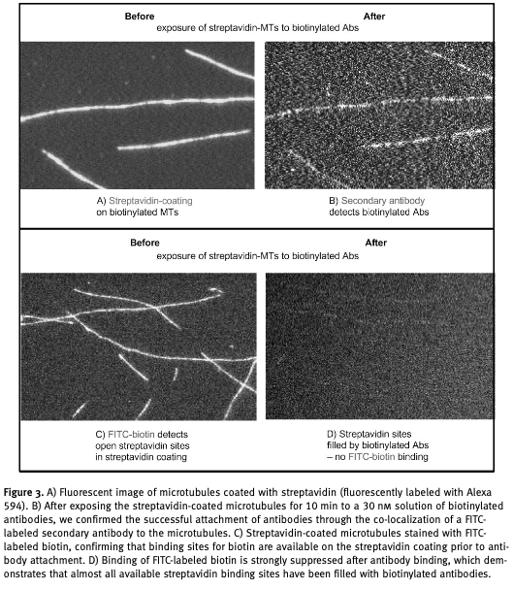

I would add scale bars to the images.

1. a. What is active transport?
2. Name and describe at least 2 other types of transport processes.
3. How is active transport different from those other transport processes? (4 points)
4. Active transport is the transport of molecules across cell membrane against its concentration gradient, using ATP as energy source.
5. Diffusion the movement of molecules from an area of higher concentration to an area of lower concentration. It is undirected and arises from the random Brownian motion of molecules.

Pressure-driven fluid flow is the movement of liquid or gas through a system from an area of high pressure to an area of low pressure. It is directed and relies on the existence of a pump.

1. Active transport requires energy input and the use of specialize pumps while diffusion and pressure-driven fluid flow are both passive processes.
2. How long does it take on average for a protein with a diffusion coefficient of D = 100 μm2/s to diffuse over a distance of r = 30 μm? (2 points)

Formula: $<r^{2}>= 6*D*t$

$$<r^{2}> = 6*D*t$$

$$t=\frac{<r^{2}>}{6*D}=\frac{(30 {μm)}^{2}}{6*100 {μm}^{2}/s }=1.5 s$$

1. a. Complete:

10 cm = nm

10 Å = m

1kBT = pN.nm

b. Answer the following questions.

What is the typical length of a covalent bond?

1-2 angstroms

What is a typical binding energy of a covalent bond? (5 points)

240 kJ/mol

1. a. What are the different types of molecular bonds?
2. How is molecular bonding different from joining parts at the macroscale? (4 points)
3. Covalent bonds, metallic bonds, and ionic bonds.
4. Molecular bonding involves chemical interactions between individual atoms or molecules and is responsible for the physical and chemical properties (such as melting point or reactivity) of the material as a whole. On the contrary, joining parts at the macroscale is typically a mechanical process (using nails and screws or welding).